Manufacturing Impact Analysis Engine (MIAE)

1. Purpose
Manufacturing organizations maintain product definitions, suppliers, inventory, purchase orders, work orders, and customer commitments across multiple systems.
While existing ERP, PLM, and MES systems can manage these entities individually, they often struggle to answer cross-functional impact questions such as:
- What happens if Revision B is released?
- What products depend on Supplier X?
- What inventory becomes obsolete?
- Which customers are affected by a component change?
- Can Revision A be retired?
- What revenue is at risk?
The Manufacturing Impact Analysis Engine (MIAE) addresses this gap by building a manufacturing knowledge graph and exposing impact analysis APIs.

2. Scope

Included in MVP

Product Definition
- Product: A product is the finished good, subassembly, or sellable item that a manufacturer designs, produces, and delivers to customers. It serves as the top-level business object that links engineering, manufacturing, procurement, inventory, and sales processes.
- Revision: A revision represents a controlled version of a product definition. Revisions are used to manage engineering changes, ensuring that manufacturing, procurement, and inventory operations reference the correct product configuration at a specific point in time.
- BOM Components: Bill of Materials (BOM) components are the raw materials, purchased parts, subassemblies, and consumables required to manufacture a product. The BOM defines what is needed, how much is needed, and the hierarchical relationship between parent assemblies and child components.

Supply Chain
- Supplier: A supplier is an external organization that provides raw materials, components, assemblies, or services required for manufacturing. Suppliers play a critical role in ensuring material availability, lead-time performance, quality compliance, and supply continuity.
- Component Supplier Mapping

Inventory
- Component Inventory Position: Component Inventory Position represents the current available quantity of a component across warehouses or storage locations. It provides visibility into stock availability, shortages, excess inventory, and potential obsolescence risks associated with engineering changes.

Procurement
- Purchase Orders: A purchase order (PO) is a commercial document issued to a supplier requesting the delivery of specified materials, quantities, and pricing. Purchase orders represent future material commitments and are a key input for supplier impact and obsolescence analysis.

Manufacturing
- Work Orders: A work order (also known as a manufacturing order or production order) is an authorized instruction to produce a specified quantity of a product by a defined date. It links product definitions, BOMs, materials, and production execution activities on the shop floor.

Sales
- Sales Orders: A sales order represents a customer commitment to purchase a product or service. It captures the requested products, quantities, pricing, and delivery requirements and serves as the primary source of demand that drives manufacturing and procurement activities.
- Customers: A customer is an organization or individual that purchases manufactured products. Customers are the ultimate recipients of product deliveries and are important for assessing the business impact of product changes, supplier disruptions, and revenue-at-risk scenarios.

Impact Analysis
- Revision Impact: Analyzes the downstream impact of a product revision on inventory, purchase orders, work orders, sales orders, customers, and revenue. Helps assess the operational consequences of introducing or evaluating a revision.

- Component Impact: Identifies where a component is used across products, revisions, inventory, procurement, and manufacturing. Helps determine the business impact of component changes, shortages, or obsolescence.
- Supplier Impact: Evaluates the effect of supplier-related disruptions by identifying dependent components, products, work orders, sales orders, customers, and revenue exposure. Helps assess supply chain risk and business impact.
- Lifecycle/Retirement Impact: Determines whether a product revision can be retired based on active operational dependencies such as open work orders and sales orders. Helps manage revision transitions and retirement readiness.

3. High-Level Architecture
ERP / PLM | v Ingestion APIs | v Projection Services | v Neo4j Knowledge Graph | v Impact Analysis Engine | v REST APIs
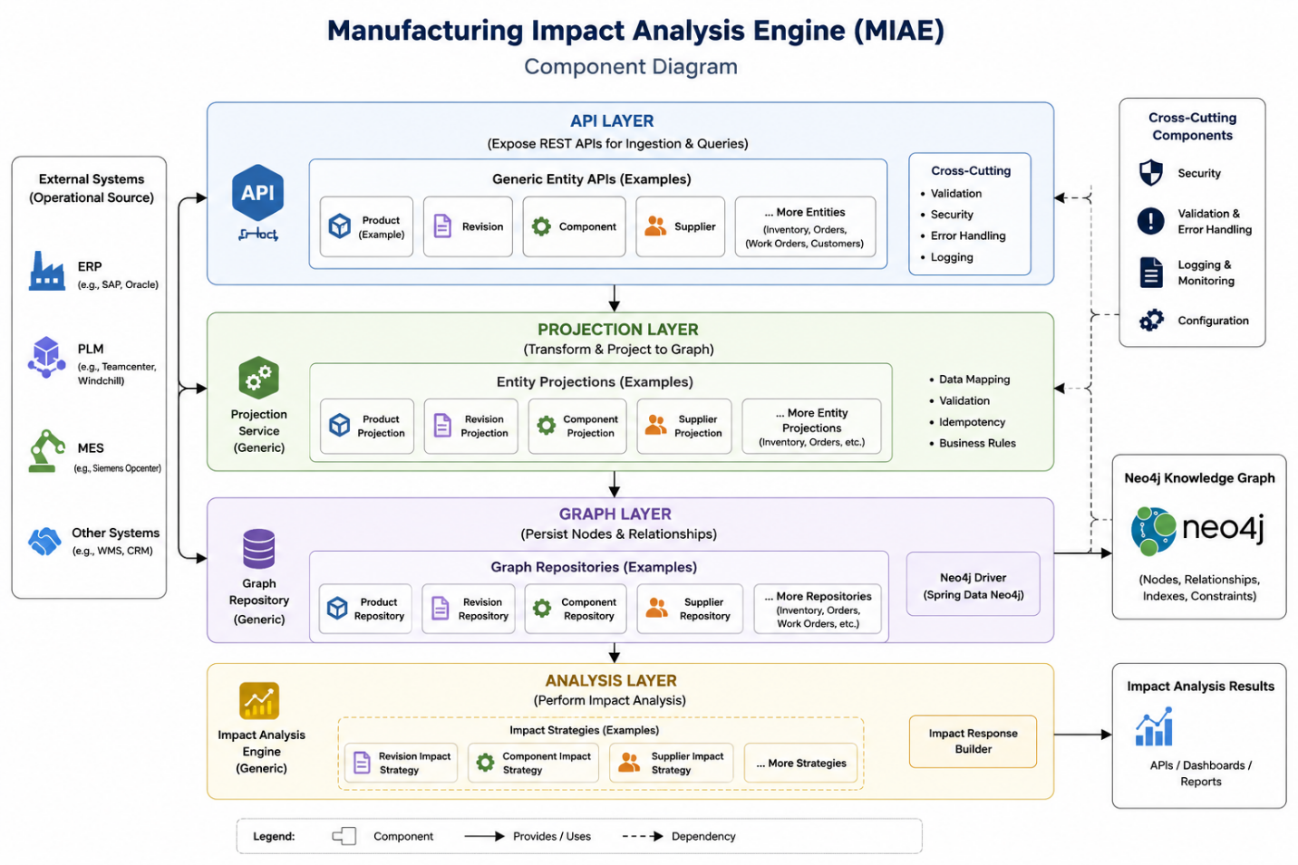

4. Technology Stack
- Java 21
- Spring Boot 3.x
- Spring Data Neo4j
- Neo4j
- Maven
- Swagger/OpenAPI
- Docker Compose

5. Manufacturing Knowledge Graph
Graph Node | Attributes Description
PRODUCT | Stores the business identity and master information of a manufactured product.
REVISION | Stores the version-specific definition, status, and lifecycle information of a product revision.
COMPONENT | Stores master data, lifecycle state, and cost information for a material or part used in manufacturing.
SUPPLIER | Stores supplier identification and sourcing information used for procurement and supply chain analysis.
INVENTORY | Stores component inventory quantities and warehouse-specific stock positions.
PURCHASE_ORDER | Stores procurement commitments, supplier references, and open material quantities.
WORK_ORDER | Stores manufacturing execution information, production status, and remaining quantities for a revision.
SALES_ORDER | Stores customer demand, order quantities, delivery commitments, and order value information.
CUSTOMER | Stores customer master information used for sales and impact analysis.

Node Graph
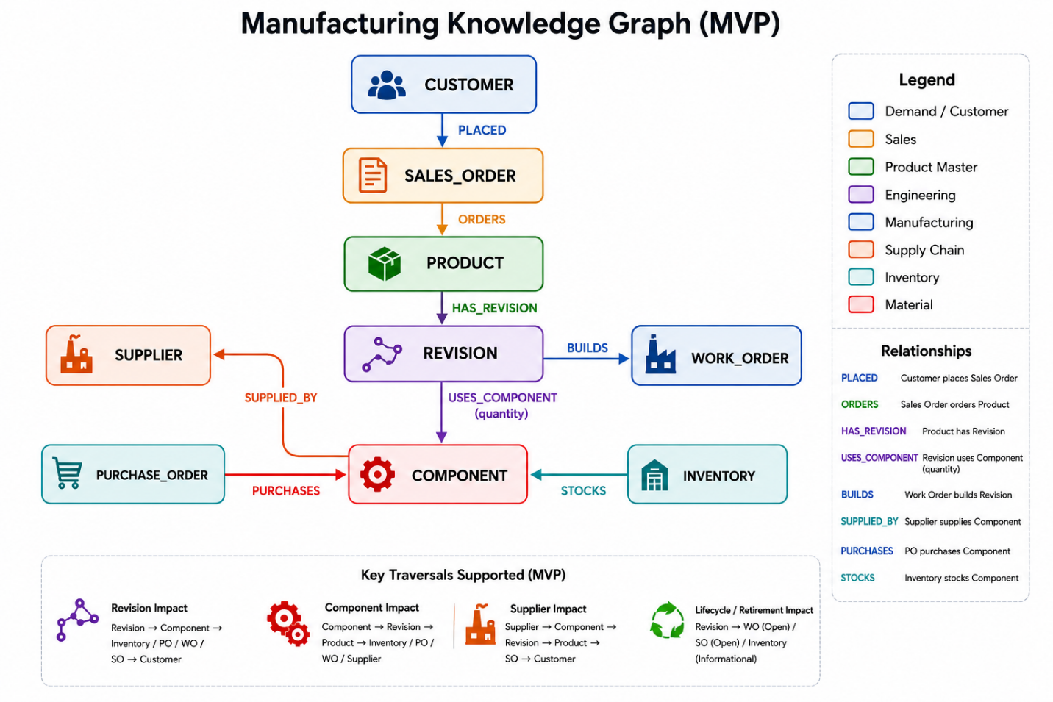

Node Types

PRODUCT
Properties:
- productId , code, name

Property | Source API | JSON Field | Description
productId | POST /api/v1/products | productId | Unique identifier of the product within the graph.
code | POST /api/v1/products | code | Business-visible product code used across manufacturing systems.
name | POST /api/v1/products | name | Human-readable product name.

REVISION
Properties:
- revisionId , code, status, productId

JSON Field | Source API | Graph Mapping | Description
revisionId | /api/v1/revisions | REVISION.revisionId | Unique identifier of the revision.
productId | /api/v1/revisions | PRODUCT lookup | Used to create HAS_REVISION relationship.
code | /api/v1/revisions | REVISION.code | Business revision identifier.
status | /api/v1/revisions | REVISION.status | Revision lifecycle status.

COMPONENT
Properties:
- componentId

JSON Field | Source API | Graph Mapping | Description
componentId | /api/v1/boms | COMPONENT.componentId | Unique component identifier.

SUPPLIER
Properties:
- supplierId

Property | Source API | JSON Field | Description
supplierId | POST /api/v1/suppliers | suppliers[].supplierId | Unique identifier of a supplier.

INVENTORY
Properties:
- inventoryId, warehouse, quantity

Property | Source API | JSON Field | Description
warehouse | POST /api/v1/inventory | warehouse | Warehouse or storage location.
componentId (COMPONENT lookup) | POST /api/v1/inventory | componentId | COMPONENT lookup
inventoryId | POST /api/v1/inventory | inventoryId
quantity | POST /api/v1/inventory | quantity | Available inventory quantity.

PURCHASE_ORDER
Properties:
- purchaseOrderId, openQuantity

Property | Source API | JSON Field | Description
purchaseOrderId | POST /api/v1/purchase-orders | purchaseOrderId | Unique purchase order identifier.
openQuantity | POST /api/v1/purchase-orders | openQuantity | Quantity yet to be received from supplier.

WORK_ORDER
Properties:
- workOrderId, status, remainingQuantity, plannedCompletionDate, priority

Property | Source API | JSON Field | Description
workOrderId | POST /api/v1/work-orders | workOrderId | Unique work order identifier.
status | POST /api/v1/work-orders | status | Current execution status of the work order.
remainingQty | POST /api/v1/work-orders | remainingQty | Quantity remaining to be manufactured.
priority | POST /api/v1/work-orders | priority | Manufacturing priority used for impact ranking.
plannedCompletionDate | POST /api/v1/work-orders | plannedCompletionDate | Planned completion date of the work order.

SALES_ORDER
Properties:
- salesOrderId ,openQuantity ,orderValue ,priority, productId

Property | Source API | JSON Field | Description
salesOrderId | POST /api/v1/sales-orders | salesOrderId | Unique sales order identifier.
openQuantity | POST /api/v1/sales-orders | openQuantity | Quantity remaining to be fulfilled.
orderValue | POST /api/v1/sales-orders | orderValue | Total monetary value of the sales order.
priority | POST /api/v1/sales-orders | priority | Business priority used for impact ranking.

CUSTOMER
Properties:
- customerId , customerName

Property | Source API | JSON Field | Description
customerId | POST /api/v1/sales-orders | customerId | Unique customer identifier.
customerName | POST /api/v1/sales-orders | customerName | Human-readable customer name.

6. Relationship Types
PRODUCT HAS_REVISION REVISION
REVISION USES_COMPONENT COMPONENT
COMPONENT SUPPLIED_BY SUPPLIER
INVENTORY STOCKS COMPONENT
PURCHASE_ORDER PURCHASES COMPONENT
WORK_ORDER BUILDS REVISION
SALES_ORDER ORDERS PRODUCT
CUSTOMER PLACED SALES_ORDER

Relationship | Source API | JSON Field | Description
PRODUCT → HAS_REVISION → REVISION | POST /api/v1/revisions | productId | Associates a revision with its parent product.
REVISION → USES_COMPONENT → COMPONENT | POST /api/v1/boms | revisionId, components[].componentId | Defines BOM structure for a revision.
COMPONENT → SUPPLIED_BY → SUPPLIER | POST /api/v1/suppliers | componentId, suppliers[].supplierId | Defines supplier sourcing for a component.
INVENTORY → STOCKS → COMPONENT | POST /api/v1/inventory | componentId | Associates inventory position with a component.
PURCHASE_ORDER → PURCHASES → COMPONENT | POST /api/v1/purchase-orders | componentId | Associates purchase order with a component.
WORK_ORDER → BUILDS → REVISION | POST /api/v1/work-orders | revisionId | Associates work order with the revision being manufactured.
SALES_ORDER → ORDERS → PRODUCT | POST /api/v1/sales-orders | productId | Associates sales order with the ordered product.
CUSTOMER → PLACED → SALES_ORDER | POST /api/v1/sales-orders | customerId | Associates customer with a sales order.

7. Ingestion API Design

Product API
POST /api/v1/products
Request:
{ “productId”: “P100”, “code”: “SENSOR-100”, “name”: “Industrial Sensor” }

Revision API
POST /api/v1/revisions
Request:
{ “revisionId”: “P100-REV-B”, “productId”: “P100”, “code”: “B”, “status”: “APPROVED” }

BOM API
POST /api/v1/boms
Request:
{ “revisionId”: “P100-REV-B”, “components”: [ { “componentId”: “PCB-B”, “quantity”: 1 }, { “componentId”: “SCREW”, “quantity”: 4 } ] }

Supplier Mapping API
POST /api/v1/suppliers
Request:
{ “componentId”: “PCB-B”, “suppliers”: [ { “supplierId”: “SUP-ABC”, “leadTimeDays”: 15 } ] }

Inventory API
POST /api/v1/inventory
Request:
{ “componentId”: “PCB-B”, “warehouse”: “WH1”, “quantity”: 500, “inventoryId” : “123INV” }

Purchase Order API
POST /api/v1/purchase-orders
Request:
{ “purchaseOrderId”: “PO-100”, “supplierId”: “SUP-ABC”, “componentId”: “PCB-B”, “openQuantity”: 1000 }

Work Order API
POST /api/v1/work-orders
Request:
{ “workOrderId”: “WO-1001”, “revisionId”: “P100-REV-B”, “status”: “RELEASED”, “remainingQty”: 50, “priority”: “HIGH”, “plannedCompletionDate”: “20/02/2026”}
Work order status common values are CREATED, RELEASED, IN_PROGRESS, COMPLETED
CANCELLED

Sales Order API
POST /api/v1/sales-orders
Request:
{ “salesOrderId”: “SO-100”, “customerId”: “CUST-100”, "customerName": "Acme Corp", “productId”: “P100”, “openQuantity”: 25, “orderValue”: 50000, “priority”: “CRITICAL”}
Priority is an Enum, accepted values are LOW, HIGH, CRITICAL

8. Impact Analysis API Design
POST /api/v1/impact-analysis
Request:
{ “entityType”: “REVISION”, “entityId”: “P100-REV-B” }
Supported entity types:
- REVISION
- COMPONENT
- SUPPLIER

9. Standard Response Model
{ “entityType”: “REVISION”, “entityId”: “P100-REV-B”,
“summary”: { “affectedProducts”: 1, “affectedInventoryRecords”: 2, “affectedPurchaseOrders”: 1, “affectedWorkOrders”: 2, “affectedSalesOrders”: 1, “affectedCustomers”: 1, “revenueAtRisk”: 50000 },
“impacts”: { “inventory”: [], “purchaseOrders”: [], “workOrders”: [], “salesOrders”: [], “customers”: [] } }
revenueAtRisk = Sum of orderValue for all affected open sales orders.

10. Impact Analysis Response Models
The Impact Analysis API supports multiple entity types. While all responses share a common envelope, each impact type returns specialized data relevant to the analysis being performed.

10.1 Revision Impact Response
Purpose: Evaluate the downstream business and operational impact of introducing, modifying, or retiring a product revision. The analysis identifies affected inventory, procurement commitments, manufacturing activities, customer orders, and revenue exposure, enabling engineering and operations teams to make informed change-management decisions.
Answer:
- What changed between revisions?
- What inventory becomes obsolete?
- Which purchase orders are affected?
- Which work orders are affected?
- Which customers are affected?
- Can previous revision be retired?

Request:
{
"entityType": "REVISION",
"entityId": "P100-REV-B"
}

Response:
{
"entityType": "REVISION",
"entityId": "P100-REV-B",
"summary": {
"affectedProducts": 1,
"affectedInventoryRecords": 2,
"affectedPurchaseOrders": 1,
"affectedWorkOrders": 2,
"affectedSalesOrders": 1,
"affectedCustomers": 1,
"revenueAtRisk": 50000
},
"changeSummary": {
"addedComponents": [
"PCB-B"
],
"removedComponents": [
"PCB-A"
]
},
"inventoryImpact": [
{
"componentId": "PCB-A",
"warehouse": "WH1",
"quantity": 500
}
],
"procurementImpact": [
{
"purchaseOrderId": "PO-100",
"componentId": "PCB-A",
"openQuantity": 1000
}
],
"manufacturingImpact": [
{
"workOrderId": "WO-1001",
"status": "RELEASED",
"remainingQty": 50
}
],
"customerImpact": [
{
"customerId": "CUST-100",
"customerName": "Acme Corp",
"salesOrderId": "SO-100"
}
],
"lifecycleImpact": {
"canRetirePreviousRevision": false,
"blockingWorkOrders": 1,
"blockingSalesOrders": 1
}
}
canRetirePreviousRevision = true only when no active dependency exists on that revision.

10.2 Component Impact Response
Purpose: Evaluate the business impact of a component across the manufacturing ecosystem. The analysis identifies where the component is used, associated inventory positions, supplier dependencies, procurement commitments, and manufacturing activities, helping assess the impact of shortages, quality issues, engineering changes, or obsolescence.
Answer:
- Where is component used?
- Which products depend on component?
- Which revisions use component?
- What inventory exists?
- Which supplier provides component?
- Which work orders depend on component?

Request:
{
"entityType": "COMPONENT",
"entityId": "PCB-A"
}

Response:
{
"entityType": "COMPONENT",
"entityId": "PCB-A",
"summary": {
"usedByProducts": 2,
"usedByRevisions": 3,
"inventoryRecords": 2,
"affectedPurchaseOrders": 1,
"affectedWorkOrders": 2,
"suppliers": 1
},
"productUsage": [
{
"productId": "P100",
"revisionId": "P100-REV-A"
},
{
"productId": "P200",
"revisionId": "P200-REV-C"
}
],
"inventory": [
{
"warehouse": "WH1",
"quantity": 500
},
{
"warehouse": "WH2",
"quantity": 120
}
],
"suppliers": [
{
"supplierId": "SUP-ABC",
"supplierName": "ABC Electronics"
}
],
"purchaseOrders": [
{
"purchaseOrderId": "PO-100",
"openQuantity": 1000
}
],
"workOrders": [
{
"workOrderId": "WO-1001",
"status": "RELEASED"
},
{
"workOrderId": "WO-1002",
"status": "IN_PROGRESS"
}
]
}

10.3 Supplier Impact Response
Purpose: Evaluate the business and operational risk associated with a supplier. The analysis identifies supplied components, dependent products, manufacturing activities, customer commitments, and revenue exposure, helping organizations assess supply-chain disruptions and supplier-related risks.
Answer:
- What happens if supplier fails?
- Which products depend on supplier?
- Which customers are affected?
- Which work orders are affected?
- What revenue is at risk?

Request:
{
"entityType": "SUPPLIER",
"entityId": "SUP-ABC"
}

Response:
{
"entityType": "SUPPLIER",
"entityId": "SUP-ABC",
"summary": {
"suppliedComponents": 3,
"affectedProducts": 5,
"affectedWorkOrders": 8,
"affectedSalesOrders": 4,
"affectedCustomers": 3,
"revenueAtRisk": 250000
},
"components": [
{
"componentId": "PCB-A"
},
{
"componentId": "PCB-B"
},
{
"componentId": "DISPLAY-01"
}
],
"affectedProducts": [
{
"productId": "P100",
"productName": "Sensor"
},
{
"productId": "P200",
"productName": "Gateway"
}
],
"affectedWorkOrders": [
{
"workOrderId": "WO-1001",
"remainingQty": 50
},
{
"workOrderId": "WO-1002",
"remainingQty": 20
}
],
"affectedSalesOrders": [
{
"salesOrderId": "SO-100",
"orderValue": 50000
},
{
"salesOrderId": "SO-101",
"orderValue": 75000
}
],
"affectedCustomers": [
{
"customerId": "CUST-100",
"customerName": "Acme Corp"
},
{
"customerId": "CUST-200",
"customerName": "Tesla"
}
]
}

11. Internal Modules
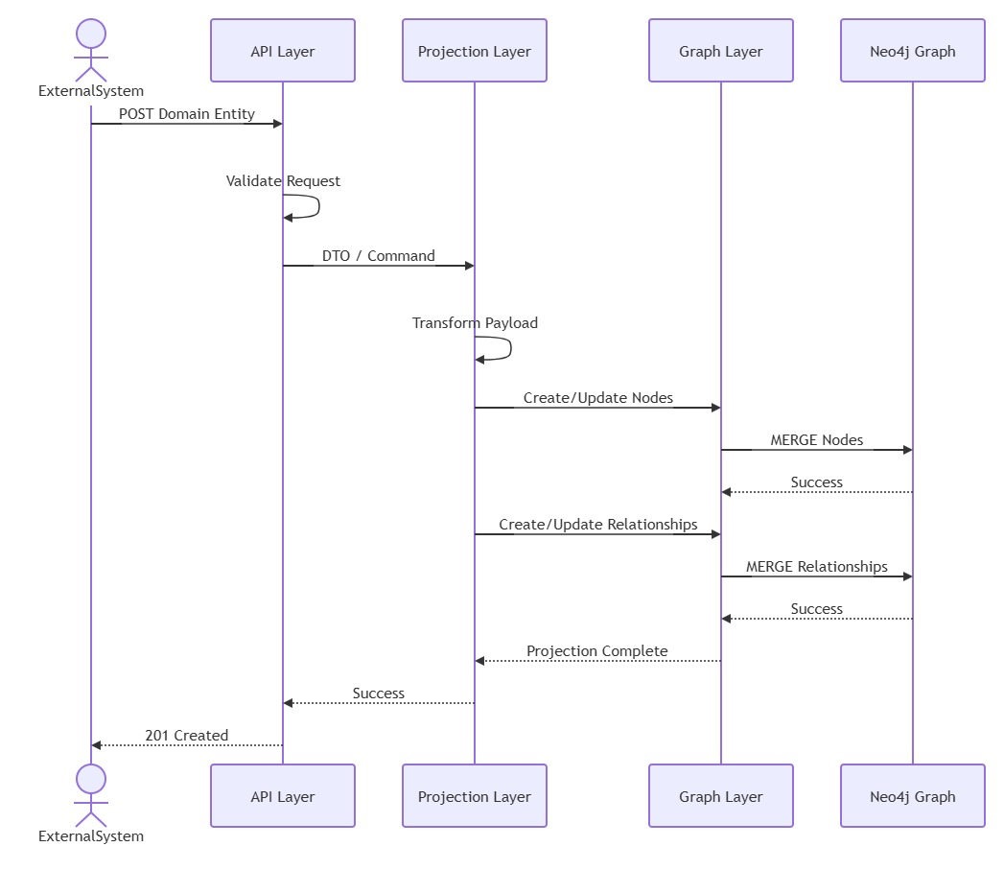

API Layer
The API Layer serves as the entry point into the Manufacturing Impact Analysis Engine and is responsible for exposing REST APIs for both data ingestion and impact analysis. It validates incoming requests, performs DTO mapping, enforces security and API contracts, and could generates OpenAPI documentation. The layer acts as a boundary between external manufacturing systems and the internal application architecture, ensuring that only valid and normalized requests are passed to downstream services.
Responsibilities:
- Request validation
- DTO mapping
- OpenAPI generation
Controllers:
- ProductController
- RevisionController
- BomController
- SupplierController
- InventoryController
- PurchaseOrderController
- WorkOrderController
- SalesOrderController
- ImpactAnalysisController

Projection Layer
The Projection Layer is responsible for transforming operational manufacturing data into graph representations suitable for storage in the knowledge graph. It converts domain payloads into nodes and relationships, applies graph-specific business rules, enriches incoming data where necessary, and orchestrates graph updates. This layer isolates graph construction logic from API and persistence concerns, ensuring a consistent and maintainable graph model across all manufacturing entities.
Responsibilities:
- Transform domain payloads into graph updates
Services:
- ProductProjectionService
- RevisionProjectionService
- BomProjectionService
- SupplierProjectionService
- InventoryProjectionService
- OrderProjectionService

Graph Layer
The Graph Layer provides an abstraction over Neo4j persistence and is responsible for creating, updating, and querying graph nodes and relationships. It encapsulates repository implementations, executes graph operations, and enforces graph integrity constraints. By isolating database interactions from business logic, the layer provides a consistent mechanism for graph persistence and retrieval while enabling future flexibility in graph storage technologies.
Responsibilities:
- Neo4j persistence
- Node creation
- Relationship creation
Repositories:
- ProductGraphRepository
- RevisionGraphRepository
- ComponentGraphRepository
- SupplierGraphRepository

Neo4j Knowledge Graph
The Neo4j Knowledge Graph serves as the system of insight for the Manufacturing Impact Analysis Engine. It stores manufacturing entities such as products, revisions, components, suppliers, inventory positions, purchase orders, work orders, sales orders, and customers as interconnected nodes and relationships. The graph model enables efficient traversal of complex dependencies across engineering, procurement, manufacturing, inventory, and sales domains, providing the foundation for impact analysis and decision support.

Analysis Layer
The Analysis Layer is responsible for traversing the manufacturing knowledge graph and evaluating the operational and business impact of changes within the manufacturing ecosystem. It executes impact analysis strategies, aggregates affected entities, calculates metrics such as revenue at risk, assesses lifecycle dependencies, and constructs standardized response models. The layer uses the Strategy Pattern to support multiple impact analysis types while maintaining a consistent processing framework.
Responsibilities:
- Traverse graph
- Aggregate impacts
- Build response model
Interfaces:
ImpactStrategy
Implementations:
- RevisionImpactStrategy
- ComponentImpactStrategy
- SupplierImpactStrategy

Common Components
Cross-cutting components provide common capabilities that are shared across all architectural layers. These capabilities include authentication, authorization, validation, exception handling, logging, monitoring, auditing, configuration management, and observability. By centralizing these concerns, the architecture ensures consistency, reduces duplication, and improves the maintainability, security, and operational visibility of the platform.

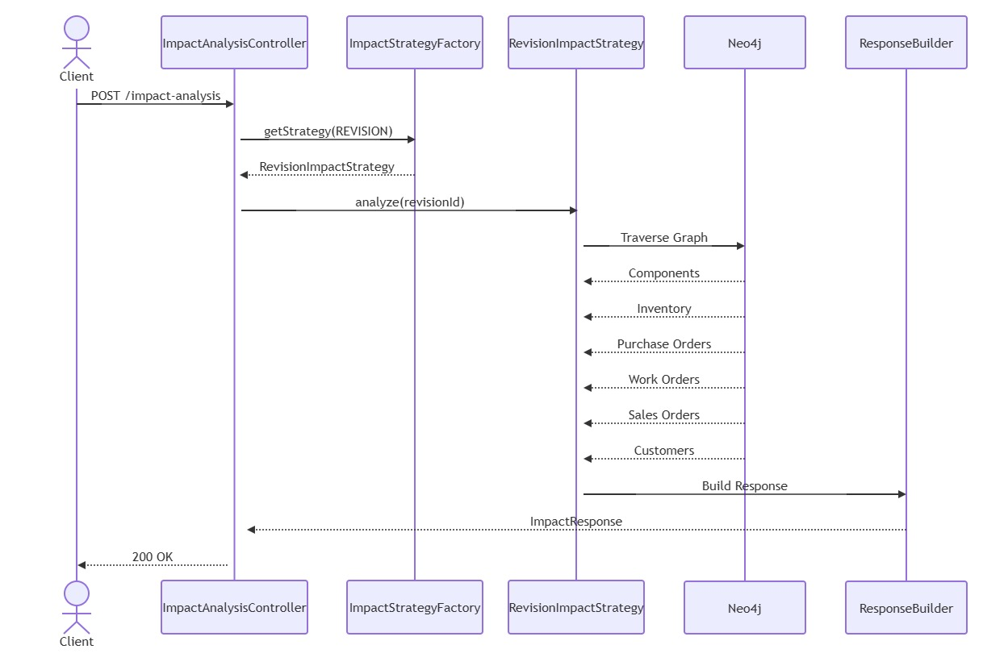

12. Security
- API Key Authentication

13. Deployment
Docker Compose
Services:
- impact-engine
- neo4j
Default Ports:
Spring Boot: 8080
Neo4j: 7474 7687

14. MVP Objectives
User can infer following from the platform:

Revision Impact
- What inventory is affected?
- What purchase orders are affected?
- What work orders are affected?
- What customers are affected?

Component Impact
- Where is component used?
- What products depend on it?
- What inventory exists?

Supplier Impact
- What products depend on supplier?
- Which customers are affected?
- What revenue is at risk?

Lifecycle Impact
- Can a revision be retired?
- What blocks retirement?

